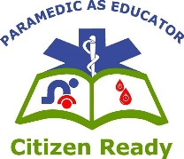
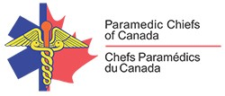
Paramedic Services Week
May 23-29, 2021
Paramedic as Educator: Citizen Ready
High Quality,
High Performance CPR

While Cardiopulmonary Resuscitation (CPR) has changed many times over the years with new research and technology, the desired outcome from CPR efforts has not.

The evolution of CPR has included an increased focus not only on WHAT we are doing or HOW we are doing, but also on the WAY we are doing it to achieve the most effective result. While the mechanics of CPR have remained relatively the same, greater focus is given to ensuring these mechanics are effective and not detrimental to our efforts. The more we know about why we are doing what we are doing or teaching, the greater likelihood these treatments will be successful in improving outcomes from sudden cardiac arrest.

Whether referred to as “High Quality” CPR (for lay rescuers) or “High Performance” CPR (for healthcare providers), it is the critical component in the success of survival from a sudden cardiac arrest and often focuses on similar elements. Simply put, it is an organized approach to significantly improve the quality of resuscitation for Sudden Cardiac Arrest (SCA) and the chance for survival of the affected person. CPR practices that reflect the concepts below are rapidly being adopted by healthcare providers and organizations and filtering into the public to lay-rescuers in modified applications where appropriate.

Some of the more important metrics include:
- Push Hard and Push Fast
- Compression Rate of 100-120/min
- Compression Depth of at least 5cm (2 inches) in adults and ≥1/3 the A/P diameter of the chest in infants and children
- Allow the chest to completely “recoil”
- “Hands-On” Time (maximize) and “Hands-Off” Time (minimize)
- No excessive ventilation
- Change compressor every 2 minutes

Quality Matters
In areas where a higher focus is made on the quality of resuscitation, survival rates can go up remarkably, even as high as 40-60%, compared to 10–14% for outdated CPR practices. Without high-performance CPR, the likelihood of survival falls by an estimated 5–10% each minute.

For the past decade, the consensus expert view on resuscitation is that we are pretty dialed in on how to do it, but not as dialed in in the way we deliver it. There is a clear gap between what providers know about how to do CPR and their actual ability to perform it well. Narrowing this gap should be the priority.

Details Matter
Research indicates that higher-quality skills, especially chest compressions, provide a higher chance for surviving Sudden Cardiac Arrest (SCA).
- Peak survival for SCA occurs at a compression rate of around 100-120 compressions per minute.
- The deeper the compression, the higher the survival rate. Compressions of at least 5 cm or 2 inches are recommended. Minor injury can occur with deeper compressions, but that should not prevent getting the deepest compression possible.
- Full chest recoil to normal position on the upstroke of compressions is critical. The effect of recoil on blood flow and SCA survival is significant and should not be underestimated.
- Blood pressure is created and maintained with ongoing compressions. When compressions stop, even for a short time, blood pressure is lost and has to slowly be built back up. Minimizing interruptions to compressions improves quality and survival.
- Excessive air volume in rescue breaths can result in complications that reduce the quality of the effort.
- Minimizing the interruption time of compressions before and after defibrillation can improve survival. With a team, the integration of using an AED when one arrives can go much more smoothly and without interrupting compressions. Compressions can be started immediately after a defibrillation shock is delivered.
- Performing chest compressions is tiring. It is unlikely a provider can maintain high-quality compressions for more than a 2 minutes. Seamlessly switching compressors every 2 minutes can help maintain compression quality.

The Dos and Don’ts of Adult High-Quality CPR

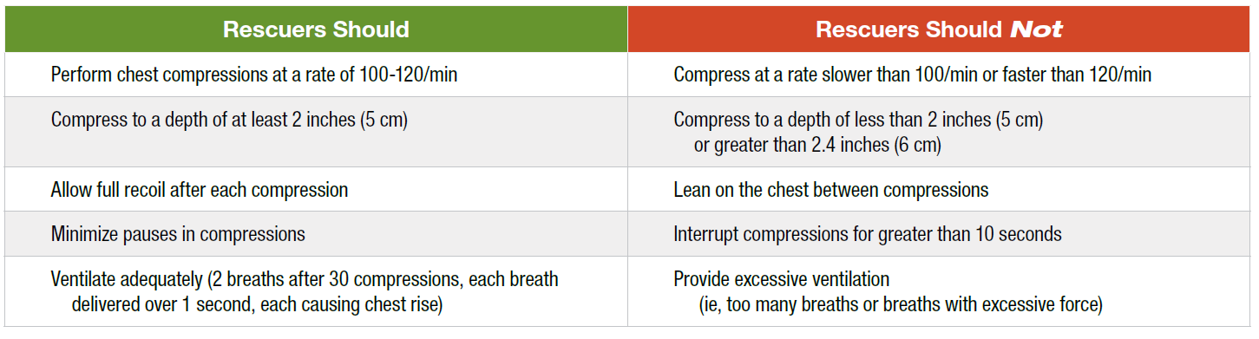

With the science of resuscitation practices is ever-evolving, the more we know the more effective we can be educating the public to be “Citizen Ready” for when they are needed.

In Partnership with ZOLL Medical Canada

Rescuers at every experience level need assistance when delivering high-performance CPR. Systems, both in and out of the hospital, that have focused on improving their CPR quality and have incorporated ZOLL technology, have doubled the odds of survival.^{3,4}
The Real CPR Help® technology on ZOLL AEDs (automated external defibrillators) and professional defibrillators assists lay rescuers and health care professionals alike in delivering high-quality CPR. Real CPR Help provides visual and audio feedback that guides rescuers to deliver CPR compressions fast enough and deep enough to save a life.
On ZOLL’s professional defibrillators, the CPR Dashboard™ displays detailed information, including the rate and depth of every compression and whether full release is being achieved. In addition, See-Thru CPR® technology filters out compression artifact so that the patient’s underlying heart rhythm can be displayed during CPR, minimizing the duration of pauses. And through Real CPR Help technology, all of the key data from the rescue effort is recorded and can be easily accessed for post-event debriefing and training.
Studies show that in over 90% of cases, ventilation delivery is either excessive or insufficient2 and that the average rate can exceed over 30 ventilations per minute.1Poor ventilation quality likely occurs due to a lack of real-time feedback. The Heart and Stroke Foundation of Canada, in the 2020 Guidelines for CPR and ECC, documents “….it is strongly recommended in advanced courses, to bring the integration of feedback devices that provide feedback on ventilation rates aligned with the most recent Guidelines Update for CPR and ECC. This is not a requirement at this time; however, it may become mandatory in the near future.”

ZOLL® is proud to introduce Real BVM Help™, a ground breaking new technology available only on ZOLL’s new X Series® Advanced monitor/defibrillator. Real BVM Help provides clinicians with real-time ventilation feedback on both rate and volume for patients managed with a simple BVM or an advanced airway.

It our pleasure to provide you with a pre-recorded “High Quality, High Performance CPR” on demand session. Delivered by ZOLL’s Clinical Marketing Team, comprised of pre-hospital healthcare professionals. Please join us for this 30 min video to celebrate Paramedic Services Week, Paramedic as Educator: Citizen Ready.

