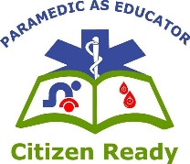
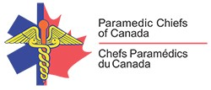
Paramedic Services Week
May 23-29, 2021
Paramedic as Educator: Citizen Ready
Control the Bleed

In as little time as it takes to read this page, someone who is severely bleeding can bleed to death…and that is not a lot of time!

With such a (short) time dependent situation as an injury that causes severe bleeding can be, immediate “Citizen Ready” action can definitively make the difference between life and death. The risks increase the longer it takes someone to help - thus highlighting the need for citizens to be aware and trained in what to do to help...quickly!

Many national (Stop the Bleed: Save a Life) and international (Stop the Bleed) programs focused on bleeding control exist, most notably one of the first was the Stop the Bleed campaign in the United States. While initiated from the tragedy at Sandy Hook Elementary School in Newtown, Connecticut demonstrating that bleeding control can improve survival in these mass trauma situations, many other scenarios like motor vehicle collisions, recreational events or even in your own home can occur and make a difference in the outcome with fast actions. Upwards of 2,400 Canadians bleed to death every year and many may have been preventable with quicker interventions.

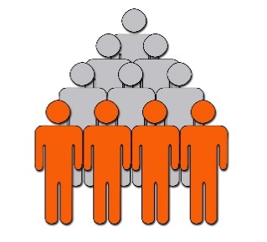
Many times, the situations that result in severe bleeding happen without warning and tragedy can follow if unprepared. Uncontrolled bleeding is a major cause of preventable deaths; more specifically from arm and leg injuries. It is believed up to 40% of trauma-related deaths worldwide are due to bleeding or its consequences, establishing hemorrhage as the most common cause of preventable death in trauma.
- Average Time to Bleed to Death2 to 5 minutes
- Average Time for First Responder to Arrive 7 to 10 minutes
- Bystanders can “Fill the Gap” and “Stop the Bleed” Seconds

The PRIORITY is simple, keep the blood (red stuff) inside the body anyway you can (safely).

The MESSAGE is even simpler, get trained in as little as 10 minutes to make the difference!

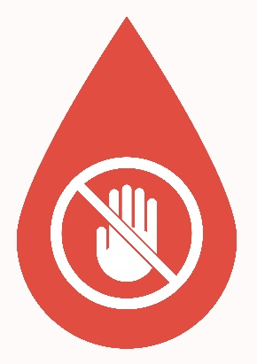
Like many situations that can vary in severity, bleeding is no different. A simple cut may only need simple direct pressure to stopping the bleeding and a bandage to keep clean. A more severe cut or injury that damages deep blood vessels causing hemorrhage will require a quicker response and much more intervention like a tourniquet or wound packing to prevent blood loss and death. Many techniques are simple to learn and can even be applied yourself when you are alone.

