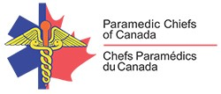
Paramedic Services Week
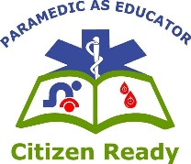
May 23-29, 2021
Paramedic as Educator: Citizen Ready
Activating 9-1-1 and Screening

In an emergency, seconds count. When medical emergencies occur, call 9-1-1 or your local emergency number (if different). Trained emergency call takers will confirm your location, assess your situation and provide you with the assistance and information you need so that the most appropriate resources can be sent to you as soon as safely possible.

During a health emergency such as the COVID-19 pandemic, when you call 9-1-1 a communication specialist (call taker) may ask you (caller) a few unique and more questions than usual. While this might seem unusual and/or unnecessary, it is critically important in ensuring the health and safety of those responding to you, like paramedics.

Why we ask what we ask?
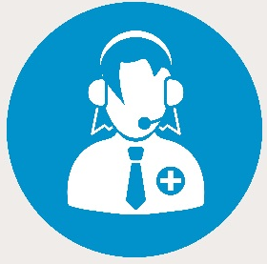
Most of why we ask what we ask when you call 9-1-1 is in an effort to best prepare those who are responding to your needs. Asking specific COVID-19 screening questions while the paramedics are responding to you will help understand what you are experiencing and how to best prepare and protect the patient, family members and the paramedics when they arrive.

While utilizing a (COVID-19) screening tool may add 30-60 seconds to call taking, the questions are just as important as any other interrogation questions call takers may ask. Medical Control Communication Centers (dispatch) have implemented a number of necessary protocols to focus on specific calls related to shortness of breath and general illness complaints.

Depending on the answers to the questions asked, the call specialist may be able to provide callers options to other non-urgent Health Lines if they don’t require urgent medical attention or transport to hospital.

Key Facts
- At home, you can dial 9-1-1 or your local emergency number (if different)
- At a business or other location, you may need to dial an outside line before dialing 9-1-1 or your local assigned emergency number.
- When using a cellular phone be prepared to give the exact location of the emergency. The call is free.
- When using a Voice over Internet Protocol (VoIP) phone, read and follow the instructions from your VoIP service provider before any emergencies, so you are prepared if you ever need to call 9-1-1.
- For TTY access (Telephone Device for the Deaf), press the space bar announcer key repeatedly until a response is received.
- If you do not speak English, you must stay on the line while the call taker possibly contacts a telephone translations service.

Paramedic Screening

- Communication specialist are trained to screen for these symptoms when taking any 9-1-1 call, and if any questions are answered “YES”, they will advise the paramedics to put on specialized personal protective equipment (PPE).
  - This is to protect both YOU and the PARAMEDICS who arrive to HELP YOU.
- When Paramedics arrive please do not approach them immediately, give them a few moments to put on the necessary PPE.
- Paramedics may then screen you again upon contact. Screening may differ slightly from province to province but they all require the same thing from each person asked:
  - COMPLETE HONSETY to screening questions.
  - You will be given the same high standard of care whether you screen positive or negative.
- Please give the paramedics space while they go through their screening, it will only take a couple seconds and remember, it’s for your safety as well.
  - There is NO EMERGENCY in a PANDEMIC.
- Some paramedic services have introduced infrared thermometers that can detect body temperature with no contact. This may be included in screening processes. Don’t be alarmed if a small ‘radar-looking gun’ in appearance is placed towards your forehead or forehead.

Tips when you Call

- Remain calm, let the Call Taker take the lead, and answer their questions clearly and concisely. Be prepared to provide the following information when asked for each piece:
  - Your name and telephone number
  - The address where the help is required, along with the precise location of the patient
  - A brief description of exactly what has happened
- Do not hang up until the call taker tells you to do so. They will have some important questions to ask and instructions to provide to you. These questions and instructions do not delay help from being sent, the answers will help to best prepare those that are responding to help you.
- You can also expect to be asked COVID-19 screening questions by the Call Taker to prepare and protect the patient, family members and the paramedics when they arrive.
- 9-1-1 answering points will generally be able to provide a translator if required.

