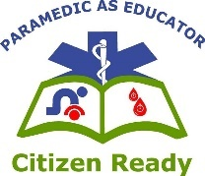
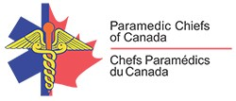
Paramedic Services Week
May 23-29, 2021
Paramedic as Educator: Citizen Ready
Emergency Preparedness
The First 72 Hours

So, What Can YOU Do?

- Prepare, Prepare and PREPARE MORE (Citizen Ready) will be the biggest influencing factors in the success of the first 72 hours of any emergency or disaster for anyone.
- Education can be focused to the importance of having to “take care of ourselves and/or family” in these situations and how to PREPARE. Do Not Rely solely on someone else to help!
- It is a difficult topic to have individuals focus on regularly because it is not something that is dealt with every day, only in extreme or occasional situations. After an event has happened; we often think either “it will never happen to me” or that “the government will take care of me” … both are a false sense of security.
  - The government has to “find” and “get” to you to help; that will take time
  - Chances are you are not alone in needing help and many others are in need as well; often more vulnerable populations are focused on first

- Because each region has its uniqueness, (1) Knowing the Risks and (2) Making a Plan are two very important steps. Educating the public on what unique elements of your community exist (railways, transportation hubs, factories or manufacturing, gas/energy distributions) and how they might impact services (i.e. water, access, etc.) helps residents think about what will impact them and reinforce the need to prepare.

- Preparing and (3) getting an Emergency Kit are also the final steps in the process in preparing for these events. Demonstrating how easy it is to “be prepared” will give comfort to those who don’t know what to take with them and when. Many of the necessities are already in the home and only need to be ready in a “Grab-in-Go Bag”.
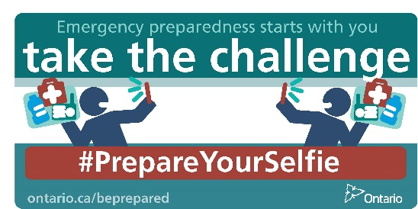
- Consider what Ontario has done as an example!

National Resources
Government of Canada Emergency Preparedness Guide
- https://www.getprepared.gc.ca/cnt/rsrcs/pblctns/yprprdnssgd/index-en.aspx
Government of Canada Emergency Preparedness Toolkit
- https://www.getprepared.gc.ca/cnt/rsrcs/ep-wk/tlkt-en.aspx
Canadian Red Cross (First 72 Hours)
- https://www.redcross.ca/about-us/red-cross-stories/2013/does-your-family-have-a-plan-for-the-first-72-hours-after-a-disaster
