Back to
school safety

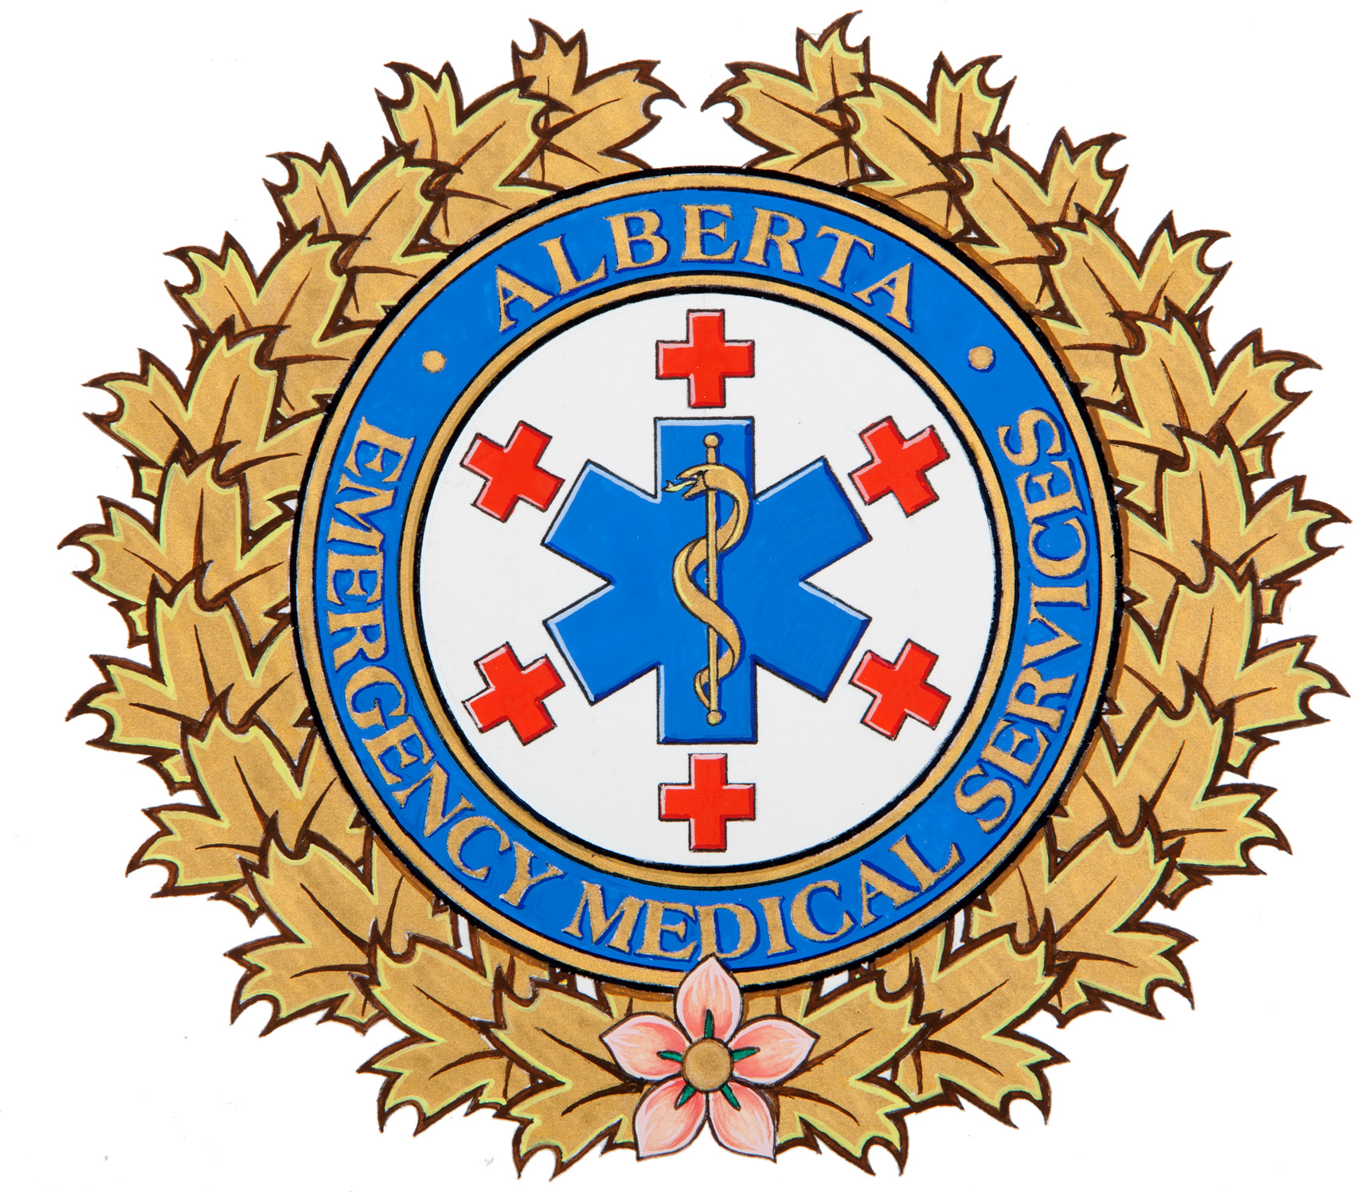

Alberta Health Services EMS would like to remind parents and students about some road safety tips, as streets become more congested, with the return of the school year. Pedestrians and motorists both have an important role to play – road safety is a shared responsibility.

Motorists
- Avoid talking on cell phones, texting, or any other behavior that diverts your attention away from driving.
- Give right-of-way to pedestrians who have activated overhead crossing lights, or who are waiting to cross from a street corner.
- Remember, it is illegal to pass vehicles - other than those that are parked - in school zones or playground zones, during posted hours.

Pedestrians
- Cross only at marked crosswalks, or street corners that have clear visibility from all directions.
- Make eye contact with all drivers before crossing the street.
- When activating overhead crossing lights, pause before stepping off the curb to ensure motorists in both directions have come to a complete stop.
- Stay within the crosswalk lines until fully clear of the roadway.
- Obey pedestrian lights at intersections. Cross the street only when you see the ‘walk’ sign and only when all cars have come to a complete stop.
- If you are with young children or pets, hold your child’s hand firmly and keep a solid grip on leashes when crossing.
- Remember: children learn by observing. By demonstrating safe crossing habits, you can reduce the chances of your child being involved in a preventable auto/pedestrian collision.

Around school buses
- Flashing amber lights mean a bus is slowing down to stop – motorists should do likewise.
- No matter which direction you are coming from, STOP, when approaching a school bus with activated flashing red lights – unless the bus is on the opposite side of a divided highway from you.
- Driver courtesy goes a long way. By simply being alert and cautious when approaching a school bus, you are contributing to school bus safety.

