Video

Shoot it
Record video of your Paramedic Services Week events and activities. It doesn’t have to be perfect. Here are some specs and tips as a guide.
Framing your video: Clips from speeches, events, activities, your own reporting….we want it!
Recording: Set your device to the highest quality setting. 1080p video is preferred.
Shooting with a DSLR or pro camera? Most file types are ok.
Shooting with a smartphone? Look here, here, and here for some tips to get good results.

Send it
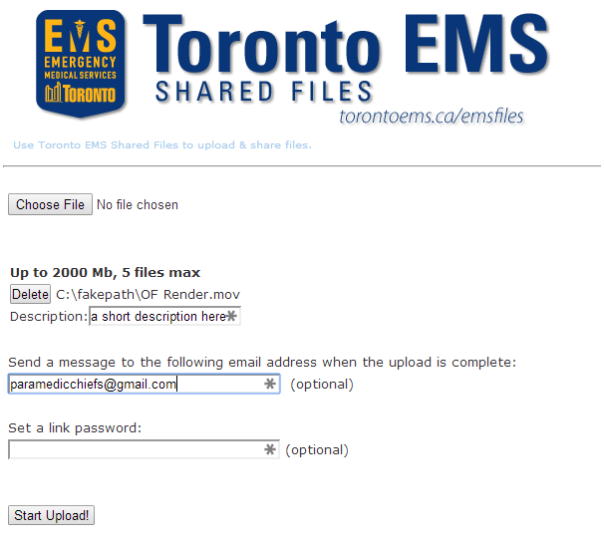
Send us your videos, please!
- Browse to http://torontoems.ca/emsfiles/
- Select the files to share “Choose File”. You can upload 2000MB at a time. Feel free to upload in multiple segments
- Be sure to enter a short description of your video so we can caption it appropriately
- Please use paramedicchiefs@gmail.com in the “Send a message too…” box so your submission goes to the right place.
- We’ll download the submissions daily at 23:00 EDT

Share it
Every night after 23:00 EDT, we’ll download them and edit the best clips together into a short segment for posting to the Paramedic Chiefs of Canada YouTube channel. A summary edit of the clips will be posted the following day to YouTube, and shared via Twitter and Facebook. Look for the #PSweek2014 tag.
Help is spread the message by sharing the posts.

Photos

Shoot it
Give it your best shot. Look to Flickr for tips on formats.

Share it
Join our Flickr pool!
Upload your photos and post them to the group. Don’t forget to tag your posts with #PSweek2014.

