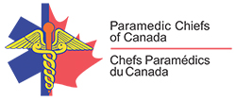
PARAMEDIC CHIEFS OF CANADA (PCC)
NOTICE OF ANNUAL GENERAL MEETING

Dear PCC member:
The Annual General Meeting of the Paramedic Chiefs of Canada has been scheduled for the following:
Date: Friday June 9th, 2017 concurrent with the PCC Conference
Time: 11:30 a.m. – 12:30 p.m.
Location: Westin Nova Scotia
1181 Hollis St
Halifax, Nova Scotia
B3H 2P6
Room: Harbour Suite

Purpose: To consider the following matters:

- Adoption of the 2016 AGM Minutes
- Nomination’s committee, election of officers – Paul Charbonneau, Chair
- President’s report - Randy Mellow
- Treasurer’s report - Gerry Schriemer
- Approval of membership fees - All
- Adjournment

